Desk Number ________

Student Number ______3349828_________________

Student Name ______Harlan De Jong_________________

**School of Electrical Engineering & Computing**

**EXAMINATION**

Semester 1, 2021

**SENG2130 Systems Analysis and Design**

*This paper is for CALLAGHAN and CENTRALCST students.*

Examination Duration: 120 minutes

This exam has 20 questions

**Exam Conditions:**

This is a TIMED EXAM (Fixed Start)

This is an OPEN book examination - While there are no restrictions placed on resources available to you, the University’s academic integrity rules, including those relating to assistance from other people, will apply.

After you have attempted this exam, you may be required to take part in a viva (or oral exam) for quality assurance purposes. A viva will consist of an interview with one or perhaps two staff conducted via Zoom, and will last approximately 10 minutes. During this time, you will be asked questions about the answers you have provided in the exam.

**Special Instructions:**

1. The distribution of marks within each question is indicated in brackets.
2. In addition to the 120 minutes indicated above, an extra 30 minutes is allocated for scanning and uploading your solutions.
3. Part A: The 15 multiple-choice questions are in the test window.
4. Part B: Download the word document
   1. Add your answers and insert your drawing images into the word document.
   2. Then upload the word document as an attached file to the part B question
   3. Name the word file: firstName_lastName_studentNumber

**Part A: (30 Marks Total)**

**The multiple choice questions are completed in the test window.**

**PART B: (70 marks total)**

All questions are to be attempted.

Insert your images into this word document.

This may be done electronically by:

1. Create the diagram an electronic drawing tool
2. Save as an image file or screen print the diagram
3. Insert your image into the word document

Or done on paper by:

1. Complete a hand drawn diagram
2. Take a photo or scan the image
3. Transfer the image to your computer
4. Insert your image into the word document

**Questions Start on the next page**

**The white space after a question does not represent how long your answer should be.**

**Question 16:** (20 marks)

Create an Activity diagram with swim-lanes based using the following narrative. Make sure you note any assumptions on the diagram.

The scenario starts when you come to the self-checkout terminal at Woolworths after choosing all your groceries. Make sure to indicate the situation where you by mistake double scan an item and needed it to be removed by the staff member.

Insert your Activity Diagram Image here.

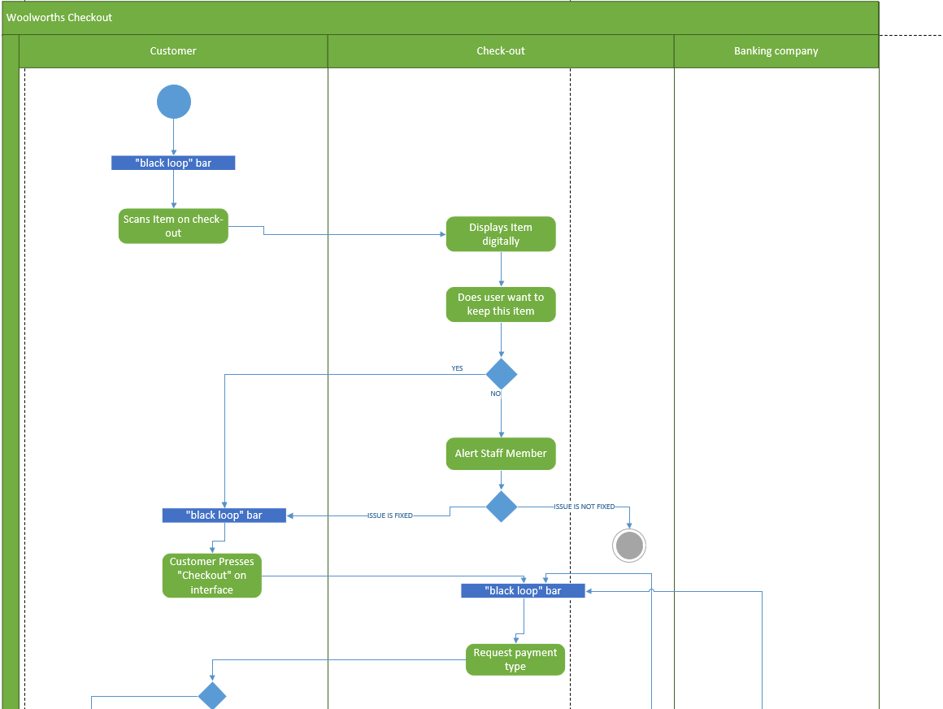

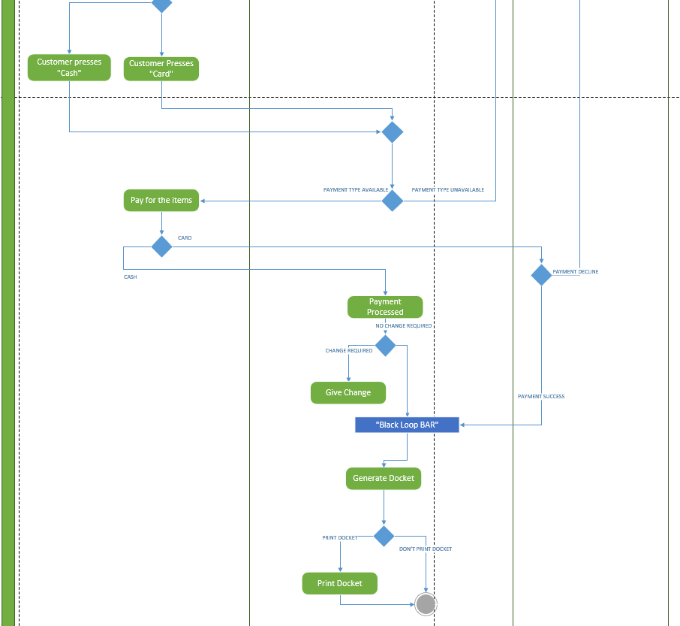

**Question 17:** (10 marks)

Testing is an integral part of system development. Four types of testing are unit testing, integration testing, system testing and acceptance testing.

Explain each one of these mentioning what is being tested, how the testing is conducted and what is the result of each test.

Enhance your answer for each type with examples from your assignment.

Write your answer here.

**Unit Testing**

Unit testing is a testing system whereby software developer look for errors in either an object or a subsystem. The goal of this testing is to ensure that the subsystems are correctly programmed to carry out the intended function. There is two major subcategories of testing within this field, they are **black box testing** and  **white box testing**.

**Black Box testing** refers to the tests where the output of the object or subsystem is tested via use cases, this test utilizes the developers knowledge of the functionality

**White Box Testing** This test refers to the checking of logical pathways amongst the code around areas such as loops, if else’s and boundary values (i.e -$100).

**Integration Testing**

Integration Testing is a testing system whereby developers look for errors within connections of subsystems. Stubs (small pieces of code) may be written in order to rectify or temporarily maintain the subsystem for work. The goal of this testing system is to test the interface among the subsystem. A top down or bottom up approach can be utilised. Top down referring to looking at layer 1 🡪 6 and bottom up referring to looking at layer 6 🡪 1. (I.e is the assignment when we made the subsystem diagrams)

**System Testing**

System testing is a testing system whereby developers test the entire systems behaviour in general, this is done via example scenarios where the systems is essentially a black box. The goal of this type of testing is to see if the system meets both the functional and non-functional requirements. Every system function will be tested ensuring all functions serve their functionality. Non-functional testing is also carried out to analyse the performance of the system as a whole. (I.e in the assignment when all the group members check that the system is cohesive as a whole)

**Acceptance Testing**

Acceptance Testing is a testing system whereby the client evaluates and assesses the system that the developers have designed for them. The goal of this testing is to show that the customers requirements are met and evaluate if the system is ready for use. The developer may be with the client to show them how the systems works which is called Alpha testing and again but with the developer not present which is called Beta Testing. As for post delivery maintenance on the developers half, regression testing is carried out on site. (I.e in the assignment if we were to deliver our final product to the CEO of Plush Meadows)

**Use the following Case Study to answer Questions 18 to 20**

**CASE STUDY –** **HomeGrocery – Online Food Shopping Service**

The HomeGrocery company sources goods from multiple supermarket chains to deliver direct to customers in their homes. It has arranged with Coles, Woolworths, Aldi, Foodworks and IGA to get listings of all their products and the prices they charge. It then provides a website where customers sign up with their name, address details (both mailing and delivery addresses), and credit card details.

Customers can then select items for purchase by picking the item and also pick which supermarket chain they want it from. This choice is usually made on price but customers may have preferences for different chains. This is particularly true of “house brands”. So for peanut butter there may be nation brand name products listed but there will also be “Peanut butter – smooth – 250g – house brand” and each supermarket chain will provide their own product in this category.

Once a customer has completed listing what they wish to order then they must confirm the full list. HomeGrocery staff in that suburb will be given the list of products ordered that day and will purchase them from the local supermarkets to produce the complete order requested by the customer. The supermarkets give a discount for the volume purchased by HomerGrocery so that is where its profit and costs are covered.

While the customers are placing their order, they can mark any item as a “regular buy”, in which case it is noted and placed in an opening list of possible purchases when the customer returns to place an order the next time.

Once back at the depot the HomeGrocery buyers will pack the different orders for different customers into cartons and deliver them to the delivery addresses. The customer will have already paid for the goods on their credit card when they ordered them online.

The HomeGrocery managers at each suburban depot will need to monitor the sales both to individual customers but also by the supermarkets being purchased from and the list of types of items being selected by customers.

HomeGrocery is expecting a number of new supermarket chains opening in Australia following the success of Aldi, with new overseas companies starting chains of stores. All of these are expecting to arrange deals with HomeGrocery.

**Question 18.** (10 marks)

Draw a Use Case diagram for the scenario implied in the case study information **HomeGrocery** Case Study.

Insert your use case diagram image here:

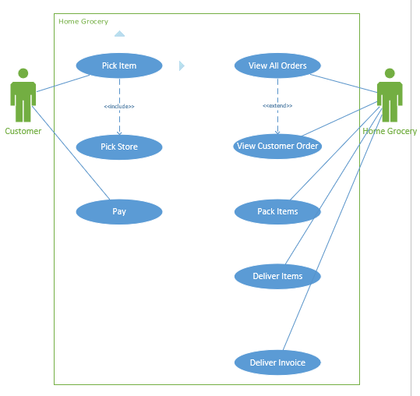

**Question 19.** (20 marks)

Draw a domain class diagram to model the basic classes in the domain for the **HomeGrocery** application, containing attributes and associations with multiplicity. There are no data types or methods in this diagram.

Insert your domain class diagram image here:

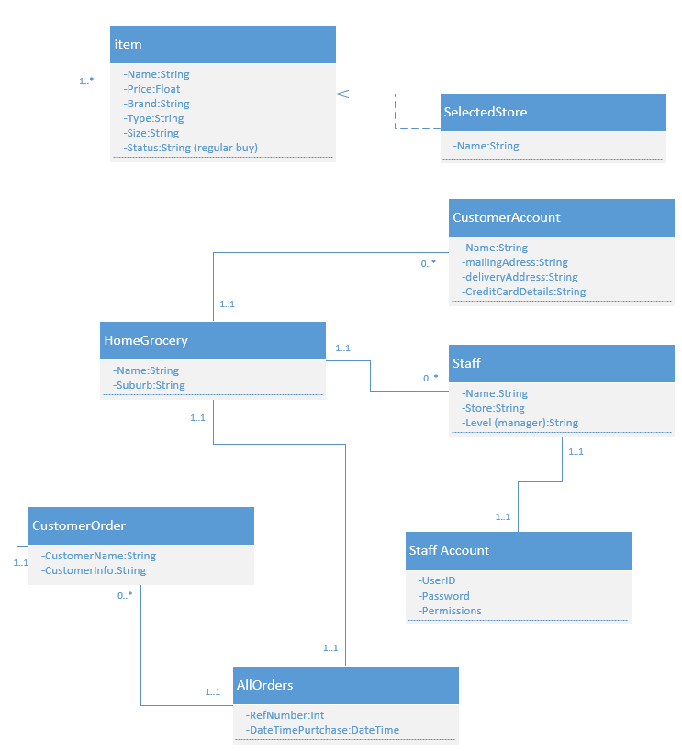

**Question 20.** (10 marks)

1. List 5 (five) functional requirements from the **HomeGrocery** and explain how you will capture each of the 5 functional requirements using UML Models.

Write your answer here

1. The system must monitor sales
2. The system must allow customers to make an account when they give their name, addresses and credit card details
3. The system must place regular buy products first for each customer
4. The system must give the customer a list of products that they have selected
5. The system must allow customers to pay online

**END OF EXAMINATION**